**EXPERIMENT – 7**

AIM :

Create Dashboard using Power BI for the Spots Data Analysis with the following information:

1. Prepare a rank ordered list of top 10 countries with most players. Which countries are producing the most numbers of footballers that plays at this level?
2. Plot the distribution of overall rating vs. age of players. Interpret what is the age after which a player stops improving?
3. Which type of offensive players tends to get paid the most: the striker, the right-winger, or the left-winger? Visualize through a plot
4. Create different types of charts, tables and Use slicers and filters effectively.
5. Design interactive dashboards.
6. Analyze the data to identify meaningful insights and make data driven decisions

**Prepare a rank ordered list of top 10 countries with most players. Which countries are producing the most numbers of footballers that plays at this level?**

**Rank-Ordered List of Top 10 Countries with Most Athletes**

We can create a measure to count the number of athletes per country and then use that

measure to rank the countries.

**2. Countries Producing the Most Footballers**

Similarly, we need to create a measure for counting footballers:

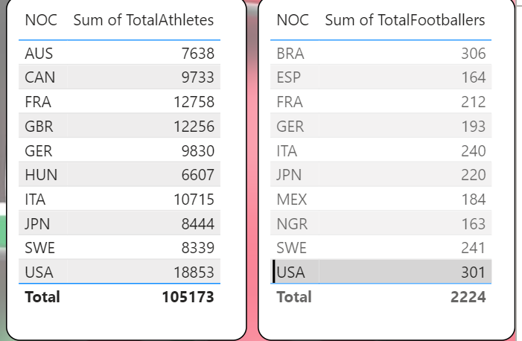

**Plot the distribution of overall rating vs. age of players. Interpret what is the age after**

**which a player stops improving?**

**Create the Medal Value Column:** Use the following DAX code to convert the

Medal column into numeric values.

**Which type of offensive players tends to get paid the most: the striker, the right-winger, or**

**the left-winger? Visualize through a plot**

Map Player Types: You can create a calculated column to categorize sports into offensive player types (Striker, Right-Winger, Left-Winger). This is an assumption based on the data you have:

**Create Different Types of Charts, Tables, and Use Slicers and Filters Effectively**

*Objective:* To visualize data in various forms to communicate insights clearly.

*Steps:*

*Add Visualizations:*

* *Select Visualization Type*: From the "Visualizations" pane, choose a chart type (e.g., bar chart, line chart, pie chart).
* *Drag Fields*: Drag and drop fields onto the visual to populate it with data.

*Customize Visuals:*

* *Format Visual:* Use the "Format" pane to customize the appearance of the visual (e.g., colors, labels, titles).
* *Add Legends and Tooltips:* Enhance visuals by adding legends and tooltips for better clarity.

*Use Slicers and Filters:*

* *Slicers:* Add slicers to allow users to filter data dynamically.
* *Filters:* Apply visual-level, page-level, or report-level filters as needed

**Design Interactive Dashboards**

Objective: To create a user-friendly and interactive interface for data exploration.

Ensure the dashboard is intuitive and user-friendly.

Interactive elements should enhance the user experience without overwhelming them.

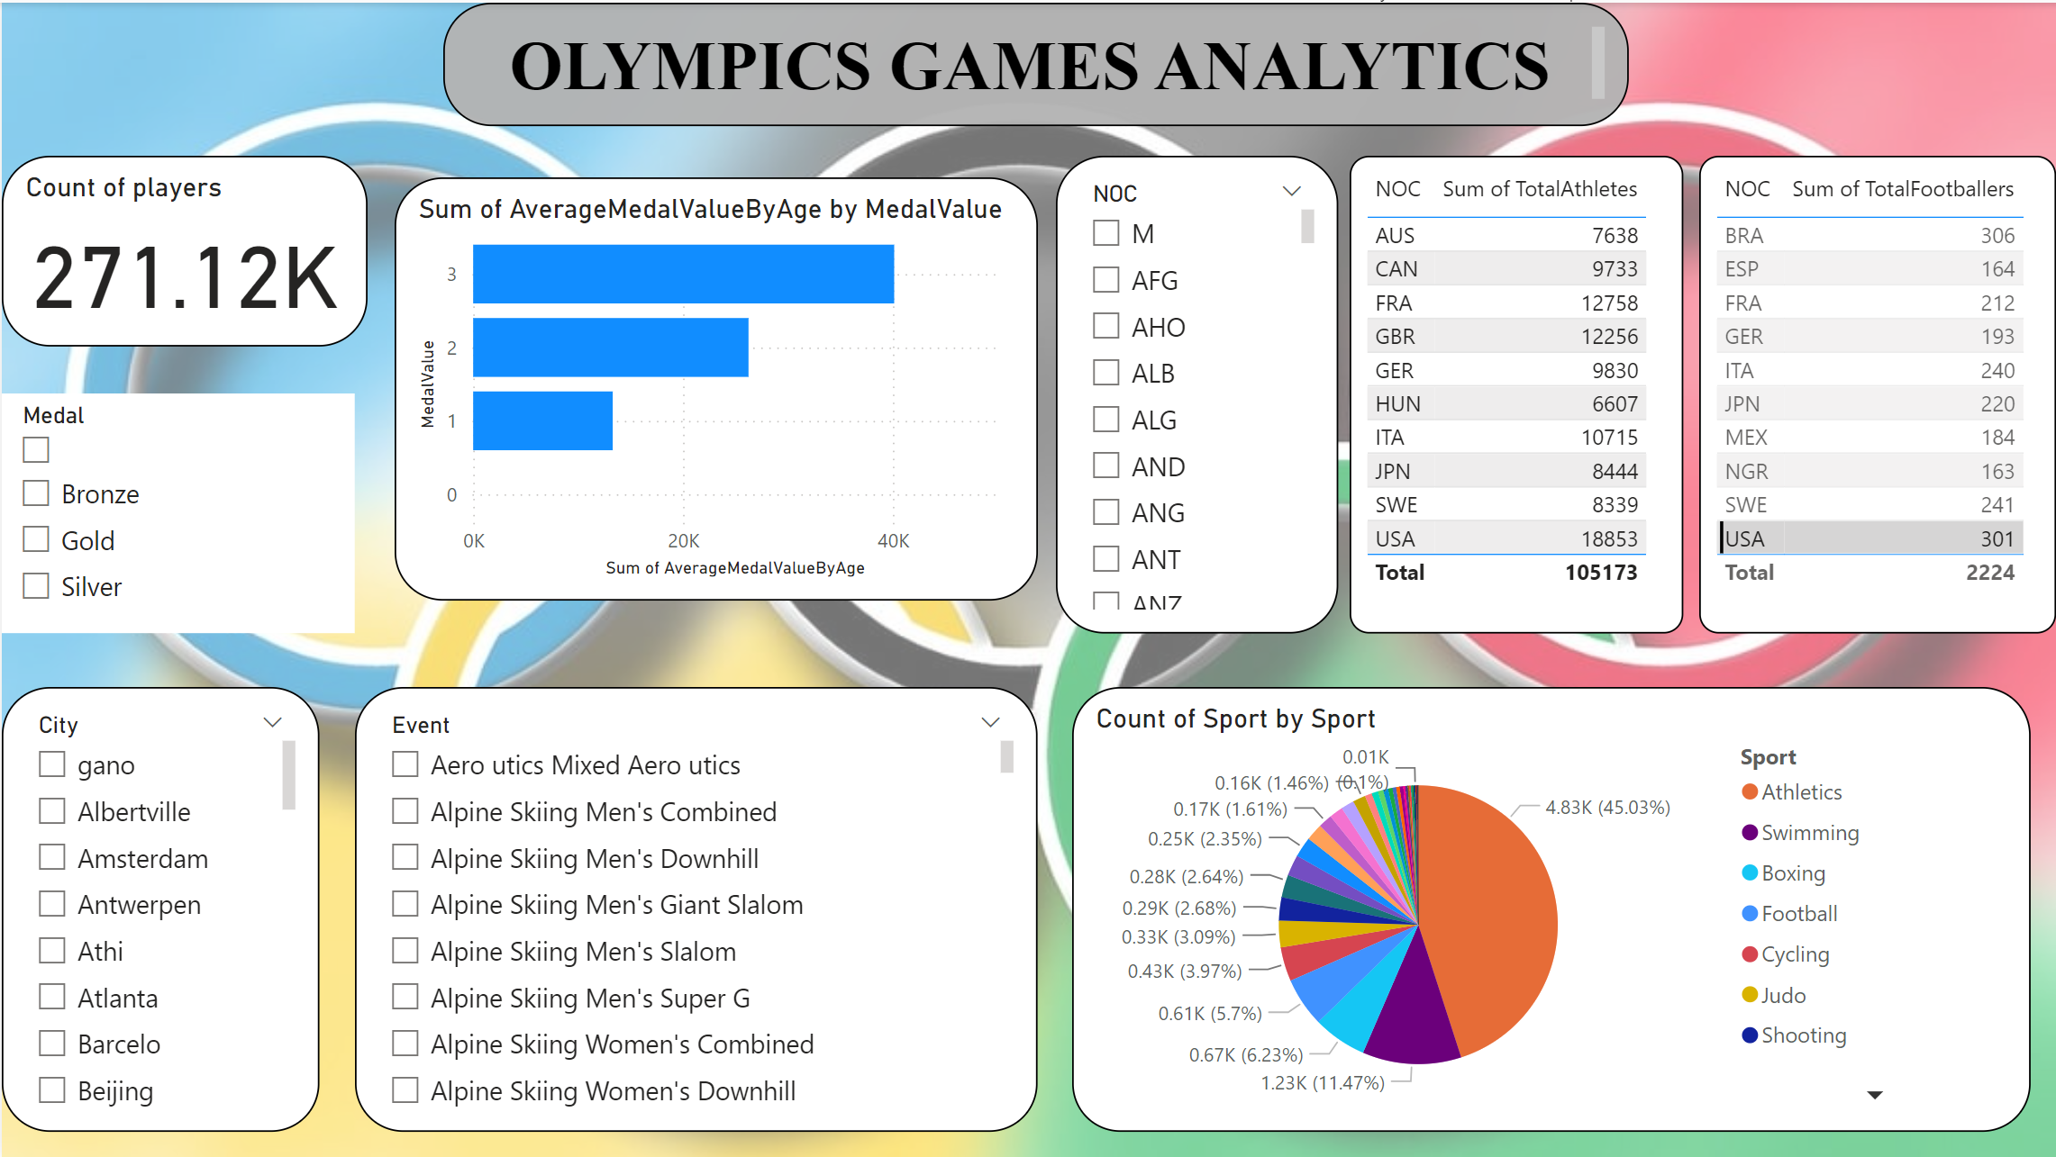

**Result:**

Olympics Games Analytics dashboard is generated according to the requirements and insights are generated from the dashboard